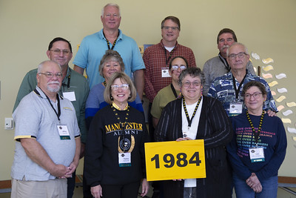

Homecoming 2024
Class of 1984
From left to right
Row 1: Jeff Shoup, Thelma Rohrer, Ronda Mendenhall, and Andi Brill Hammond
Row 2: Daniel Bogunia, Nina Bogunia, Diana Roop Hart, and Todd Hammond
Row 3: David Clark, Jim Brumbaugh-Smith, and Monte Pickens

